Curriculum Vitae
Name: Gitika Borah

Assistant Professor
Department of Political Science
Nagaon University
Nagaon, Assam

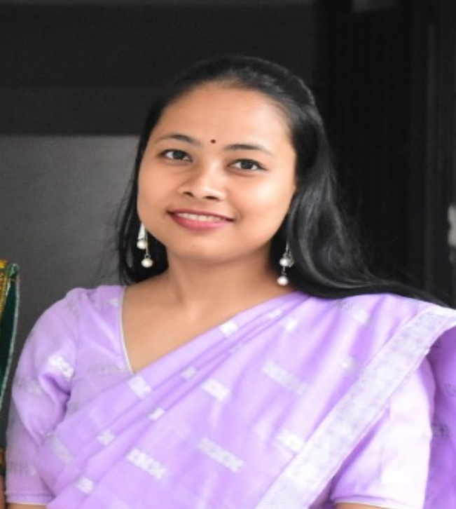

Postal Address Permanent Address
Gitika Borah, Assistant Professor, Gitika Borah
Department of Political Science, Vill & P.O.- Haleswar
Nowgong College (A), Nagaon, Tezpur, Sonitpur, Assam
Assam, Pin- 782001 Pin- 784104
Mobile: 7399866732 Mobile: 7399866732

Designation: Assistant Professor
Institutional Address: Department of Political Science, Nagaon University, Nagaon, Assam

Education:

Examination Passed | Year | Marks (%age)/ CGPA | Board/Council/ University
HSLC | 2010 | 85.33% (1st Div with DSTN) | SEBA
HS | 2012 | 84.6% | AHSEC
BA | 2015 | 85% | GU
MA | 2017 | 73% (2nd Rank) | GU
MPhil | 2020 |  | GU

Research:

Degree | University | Thesis/Dissertation | Year of Award
M.Phil. | GU | India-China Relations in the 21st Century: Understanding the Indian Response to China’s BRI | 2020
Ph.D. | GU | Soft Power & Regional Diplomacy: India’s engagement with South East Asia

Publications:
- Rights of the Indigenous Peoples: An Understanding from Gendered Perspective published in Social Action (UGC CARE), July - September 2019 Volume 69 No. 03, pp-199-212,
Link-https://isidelhi.org.in/wp-content/Social%20Action/3_%20SA%20JULY-SEPT%202019.pdf
- The Impact of Online Education on the University Students of Assam in COVID times in Indian Journal of Science and Technology, Volume 14, Issue 13. (Web of Science), April 202, pp- 1028-1035 , URL- https://indjst.org/articles/the-impact-of-online-education-on-the-university-students-of-assam-in-covid-times, DOI- 10.17485/IJST/v14i13.1809
- “Infertility, Assisted Reproductive Technology and Motherhood in the Context of Indian Society” in International Journal of Current Research and Review DOI:http://dx.doi.org/10.31782/IJCRR.2021.13917, Vol 13, Issue 09, May 2021, pp-22-25.
- “The Great Indian Kitchen: Serving the Story of an Indian Woman” published in Inclusive (UGC CARE), Volume 2 Issue 21, 2022/08, pp-208-211, URL- https://inclusivejournal.in/issue/
- Political Undercurrents in Mamang Dai’s Poetry: A Critical Examination within the Context of North East India's Lost Forests, Towns and the River published in Noesis Literary, Vol 1, Issue 1, 2024, pp-13-23, URL- https://noesisliterary.com/political-undercurrents-in-mamang-dais-poetry-a-critical-examination-within-the-context-of-north-east-indias-lost-forests-towns-and-the-river
- Creative Humanism in the Philosophy of Sankaradeva published in Noesis Literary, Vol 2, Issue 1, 2025, pp-70-80, URL- https://noesisliterary.com/creative-humanism-in-the-philosophy-of-sankaradeva.
DOI: https://doi.org/10.69627/NOL2025VOL2ISS1-05

Book Chapters:
- Research Article titled Public Policy Making in India: An Assessment of Midday Meal Scheme in Assam in Politics Governance Citizenship and Nationalism: India through North East published by Purbayan Publication, 2020, ISSN-978-93-89940-22-0
- Research Article titled Livelihood Security and Women in India in The Quest published by Saraswati Publication, 2020, ISSN-978-81-943269-3-9
- Contributed a book chapter for MA in Political Science (under CBCS), Gauhati University, IDOL, Paper-1036, International Relations-I
- Contributed a book chapter for Perspectives on International Relations and World History for BA (H) CBCS, 3rd Semester by EBH Publishers, 2022, ISSN-9789392038198
- Contributed a chapter titled “Rights of the Girl Child of India: The Institutional Mechanism and its challenges” in the book ‘The Women Question’, 2024, ISBN- 978-81-976661-9-3

Seminar/ Conference Papers Presented:

- Presented a research paper titled ‘Co-Production of Science and Social Order: Removing the Taboos on Menstruation’ at the ICSSR sponsored National Seminar on “Co-Production of Science and Social Order: A Social Science Perspective on Gifts of Science to Society for Overall Development” organized by Nowgong College, Nagaon, Assam on 17th & 18th August, 2018.
- Presented a paper on ‘India-China Relations in the 21st Century: Understanding the Indian Response to China’s Belt and Road Initiative’ at the National Young Scholars’ Meet, organised by the Department of Political Science, Gauhati University on 13th December, 2018.
- Presented a paper titled ‘India’s Act East Policy and the North East Region: Prospects for Future’ in the National Conference on “Issues in North East India & the Role of ODL and OER in Higher Education” held at GU IDOL, on March 19-20, 2019 organised by Gauhati University Institute of Distance and Open Learning.
- Presented a paper on ‘Significance of Community Participation in Environment Management’ in the National Seminar on Science, Society and Sustainable Development (SSS-19), on 3rd and 4th May, 2019 organised by Jawaharlal Nehru College, Boko.
- Presented a paper on ‘The challenges of Globalisation on Indigenous Societies’ in the ICSSR sponsored National Seminar on Ethnicity, Identity and Politics: Quest for Peace and Development’ held on 1st and 2nd November, 2019 at Sonapur College.
- Presented a paper on ‘Power Interplay in the Indian Ocean and India’s Changing Maritime Strategy’ in the International e-conference VIJIGISHU 2021 organised by Amity University in collaboration with Nepal Institute for International Cooperation and Engagement (NIICE) from 22nd to 24th September 2021.
- Presented a paper on ‘The Atmanirbhar Bharat Abhiyan: India’s way ahead’ in the ICSSR sponsored National Seminar on Atmanirbhar Bharat: Opportunities and Challenges in North-East India and Way Forward organised by Department of Economics, Nowgong College (A) from 23rd to 24th September, 2022.
- Presented a paper on ‘Opportunities and challenges of development in India’s North Eastern region: An analysis of India’s Act East Policy’ in the ICSSR sponsored National Seminar on Synergies of Development, Peace and National Security: Contextualizing the North East Region in India’s Geopolitics organised by Department of Political Science, Nowgong College (A) from 3rd and 4th November, 2022.
- Presented a paper on India’s Diasporic Linkage with South East Asia: The Malaysian Experience at Research Scholars’ Conclave on 13th September, 2023 organised by the Centre for South East Asian Studies, Gauhati University.
- Presented a paper titled ‘NEP 2020 and Online Education: Opportunities and Challenges’ in the National Seminar on Trends and Issues in Quality of Higher Education in India with Special Reference to North East India organised by IQAC, Nowgong College (A) in collaboration with NAAC on 19th- 20th October, 2023
- Presented a paper titled ‘Challenges of Handloom Industry of Assam: A Case Study of Nagaon District of Assam’ in the ICSSR sponsored National Seminar on Cultural Heritage of the North Eastern Region for Self-reliant India: Challenges and Opportunities organised by Department of History, Nowgong College (A) from 3rd November to 4th November, 2023
- Presented a paper titled ‘Displacement made by River-Bank Erosion in Assam and the issues of Security: A Case of Dhing Mouza of Nagaon District of Assam’ in the ICSSR sponsored National Seminar on Gender Discrimination at the Workplace and Women’s Mental Health: An Interdisciplinary Approach organised by Department of English, Nowgong College (A) on 28 December, 2023 to 29 December, 2023.
- Presented a paper titled ‘Creative Humanism in the philosophy of Sankaradeva’ in the International Seminar organised by Ai Kanaklata Mahila Tirtha, Assam in collaboration with Visva Bharati University on 19th and 20th February, 2024.
- Presented a paper titled ‘Indigenous Traditional Knowledge and its preservation: A Study on the Jewellery Industry of Ranthali, Assam’ in the ICSSR sponsored International Conference on Traditional Knowledge (Exploring Traditional Knowledge: Bridging Past and Future) organised by IQAC, Nowgong College (A) on 22nd and 23rd March, 2024
- Presented a paper titled ‘Assamese Creative Literature and the Issue of Migration: With Special reference to Axirbador Rong by Arun Sharma and Bangal Bahu Dur by Nandita Devi’ in the International Seminar organised by Department of Bengali, Lumding College in collaboration with Department of Bengali, Govt. B.L. College, Khulna, Bangladesh, Department of Bengali, Rabindranath Tagore University on 29th of April, 2024.
- Presented a paper titled ‘Sankardeva’s Progressive Universalism: An Analysis of his Contribution to the Religious and Socio-Cultural life of Assam’ in the National Seminar on organised by Department of Hindi in association with Kendriya Hindi Sansthan and IQAC, Nowgong College (A) on 25th October 2024.

- Worked as Joint Secretary of the ICSSR sponsored National Seminar on Synergies of Development, Peace and National Security: Contextualizing the North East Region in India’s Geopolitics organized by Department of Political Science, Nowgong College (A), dated 3rd and 4th November, 2022
- Invited Lecture on Indian Foreign Policy: Continuity and Change organised by Department of Political Science, Mahapurusha Srimanta Sankaradeva Viswavidyalaya on 6th December, 2023

Experience:

- Worked as Field Investigator in various surveys sponsored by Lokniti-CSDS, New Delhi.
- Worked at the department of Political Science, the Assam Royal Global University as Assistant Professor from October 2019 to February 2020.

Workshop/FDP participated:
- Participated in a UGC sponsored three months Foundation course on Human Rights and Duties from 8th Feb to 3rd May, 2015 organised by the Centre for Human Rights, Department of Political Science, Darrang College, Tezpur, Assam.
- Participated in a Workshop on “Application of Methods and Techniques in Contemporary Research” organized by Department of Geography, Gauhati University on 22nd and 23rd September, 2017
- Participated in a 4 week Induction/ Orientation Programme for “Faculty in Universities/ Colleges/ Institutes of Higher Education” from May 18th to 17th June, 2021 organised by the Teaching Learning Centre, Ramanujan College, University of Delhi.
- Participated in a week long Online Workshop/ FDP on Online Evaluation Systems organised by Teaching Learning Centre, Tezpur University in association with Nowgong College (A) from 22nd to 28th June, 2021.
- Participated in a week long FDP on Academic Writing and Publication organised by Teaching Learning Centre, Tezpur University 10th to 16th May, 2022.
- Participated in a UGC approved short term PDP on ‘Implementation of NEP-2020’ organised by IGNOU from 12-20 June, 2023.
- Participated in the 1 Week Online Workshop on Ethics and Research Paper Writing in Scientific and Humanities Journals organised by UGC-MMTTC, Gauhati University from 11th to 17th March 2024.
- Participated in the NEP 2020 Orientation and Sensitization Programme under MMTTP of UGC organized by MMTTC, Gauhati University from 05/06/2024 to 14/06/2024
- Completed the Multi-Disciplinary Refresher Programme entitled, “Indian Knowledge System in the Context of Higher Education: Relevance and implications in the contemporary era” organized by UGC-MMTTC, Assam University, Silchar during March 27th to April 11th, 2025.

