CURRICULUM VITAE
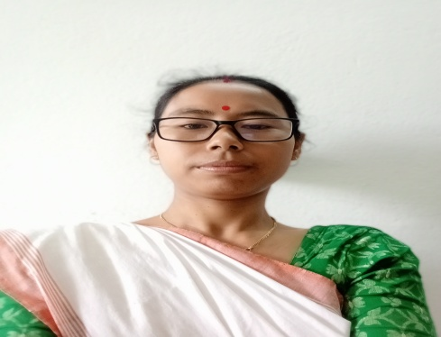
Dr. Dipalee Haflongber
M. A., B. ED., NET, SLET, JRF, Ph. D.
Assistant Professor
Department of Education
Nowgong University, Nagaon, Assam, India.
Contact No. 7086810745
Email Id: haflongberdipalee@gmail.com
Teaching Area of Interest: Educational Sociology, Educational Psychology, Educational Research, Teacher Education and Educational Management.
Research Area of Interest: Educational Sociology, Educational Psychology, Teacher Education, Primary Education, Secondary Education and Higher Education
Brief Biography : Dr. Dipalee Haflongber was born on 12th July 1985 at village- Rajbari II, Diyungbra, Dima Hsao. She is the eldest daughter of Mr. Dwijendra Lal Haflongber and Mrs. Birota Haflongber. She passed H. S. L. C. Examination from J. B. Hagjer High School, H. S. from Diphu Govt. College, B. A. from Lanka Mahavidyalaya, M. A. (Education) from Gauhati University, B. Ed. from Krishna Bora B. Ed. College and Ph. D. from Gauhati University. She cleared UGC NET, SLET and JRF. Now, She has been serving as an Assistant Professor in Department of Education, Nowgong College (Autonomous) since 21st October, 2017. She has published 19 research papers having social significance, paper presented nos. 24 in national seminars and 4 in international seminars.

