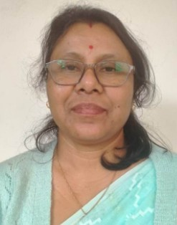 |  |  | SHIRUMONI HAZARIKA  Experience  January 2016 – Present  Associate Professor • Nowgong College  Jan 2003-jan 2016  Assistant Professor: Nowgong College,  - Develop and revise syllabi, ensuring alignment with academic standards and student learning outcomes.  - Taught undergraduate and postgraduate courses, employing interactive teaching methodologies.  District level Award in Higher Secondary  EDUCATION  - Doctor of Philosophy (Ph.D.) in Sankardeva Studies  MSSV, Nagaon -on going  - Master of Arts in Medieval Indian History  Dibrugarh University, Dibrugarh - June 2002  - Bachelor of Arts in History  DHSK College, Dibrugarh - June 1999  ACADEMIC & INSTITUTIONAL CONTRIBUTIONS  - Life Memberships: North East India History Association (NEIHA)  - Kamarupa Anusandhan Samiti  - Asom Sahitya Sabha  - Asom Science Society  COMMITTEE MEMBERSHIPS  - Vigilance Committee  - Anti-Ragging Committee  - Cultural Committee  - GS CASH Committee  - Coordinator – Add-on Course Programs  - Documentation Cell  - IQAC  - LANGUAGES  - English  - Hindi  - Assamese
 | Nagaon, Assam, India 782001
 | 8638752545
 | shirumonihazarika@gmail.com

Professional Summary
Dedicated and experienced academic professional with a strong background in higher education, specializing in history and student development. Committed to fostering an engaging learning environment through innovative teaching methodologies.

